|  |  |  |
| --- | --- | --- |
| **Cloud Group** | **Cloud Height** | **Cloud Types** |
| High Clouds = **Cirrus** | Above 18,000 feet | Cirrus- High Curled- fair weather – 24 hr. change? Cirrostratus- High Curled layers- 12-24 hr: rain or snow Cirrocumulus- High Curled heaps – nice, cold weather |
| Middle Clouds = **Alto** | 6,500 feet to 18,000 feet | Altostratus- Medium layers- could be a storm Altocumulus- Medium heaps- could be thunderstorm |
| Low Clouds = **Stratus** | Up to 6,500 feet | Stratus- Low layers – light mist, drizzle Stratocumulus-Low heaps – can turn to nimbostratus Nimbostratus-Low rainy layers – light to moderate rain |

|  |  |
| --- | --- |
| **Clouds with Vertical Growth** | Cumulus-heaped – fair weather cloud, can turn to C. nimbus Cumulonimbus-heaped rainy – bad weather! |

**There are four types of clouds: curled, layered, heaped and rain. There can be combinations of these in the same cloud.**

**Root words: Nimbus-rain; Cumulus-heap; Cirrus-curl; and Stratus-layer**.

**Great website for practice.** <http://www.mlms.logan.k12.ut.us/science/weather/cloud_types.htm>

**[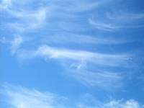](javascript:Start('cirrus.jpg'))Cirrus Clouds-High clouds**

[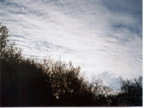](javascript:Start('cirrostratus.jpg'))**Cirrus-** Most common of the high clouds. Composed of ice and are thin, wispy clouds blown in high winds into long streamers. Usually white and predict fair to pleasant weather. By watching the movement of cirrus clouds you can tell from which direction weather is approaching. When you see cirrus clouds, it usually indicates that a change in the weather will occur within 24 hours.

**Cirrostratus clouds** are thin, sheetlike high clouds that often cover the entire sky. So thin the sun and moon can be seen through them. Cirrostratus clouds usually come 12-24 hours before a rain or snow storm.

[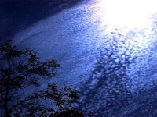](javascript:Start('cirrocumulus.jpg'))**Cirrocumulus clouds** appear as small, rounded white puffs that appear in long rows. Resemble the scales of a fish. Cirrocumulus clouds are usually seen in the winter and indicate fair, but cold weather.

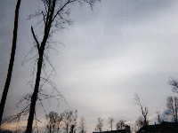

**"Alto" Clouds**-**Middle height**  
**Altostratus clouds** are gray or blue-gray *mid level* clouds composed of ice crystals and water droplets. The clouds usually cover the entire sky. Altostratus clouds often form ahead of storms with continuous rain or snow.

[](javascript:Start('altocumulus.jpg'))

**Altocumulus clouds** are mid level clouds that are made of water droplets and appear as gray puffy masses. They usually form in groups. If you see altocumulus clouds on a warm, sticky morning, be prepared to see thunderstorms late in the afternoon.

[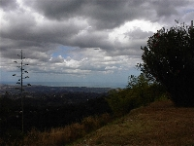](javascript:Start('stratocumulus.jpg'))[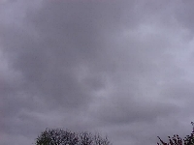](javascript:Start('stratus.jpg'))**Stratus Clouds-Low clouds**  
**Stratus clouds** are uniform grayish clouds that often cover the entire sky. They resemble fog that doesn't reach the ground. Light mist or drizzle sometimes falls out of these clouds.

**Stratocumulus clouds** are low, puffy and gray. Most form in rows with blue sky visible in between them. Rain rarely occurs with stratocumulus clouds, however, they can turn into nimbostratus clouds.

[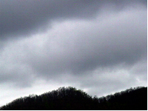](javascript:Start('nimbostratus.jpg'))**Nimbostratus clouds** form a dark gray, wet looking cloudy layer associated with continuously falling rain or snow. They often produce precipitation that is usually light to moderate.

[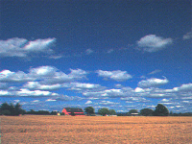](javascript:Start('cumulus.jpg'))

**Cumulus Clouds-Vertical growth**  
**Cumulus clouds** are white, puffy clouds. Called the"fair-weather clouds". The base of each cloud it flat and the top of each cloud has rounded towers. These clouds grow upward and they can develop into giant cumulonimbus clouds, which are thunderstorm clouds.

[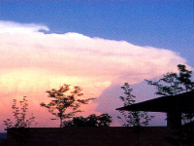](javascript:Start('cumulonimbus.jpg'))

**Cumulonimbus clouds** are thunderstorm clouds. High winds can flatten the top of the cloud into an anvil-like shape. Cumulonimbus clouds are associated with heavy rain, snow, hail, lightning and even tornadoes. The anvil usually points in the direction the storm is moving.